DATA

Technical test

Hi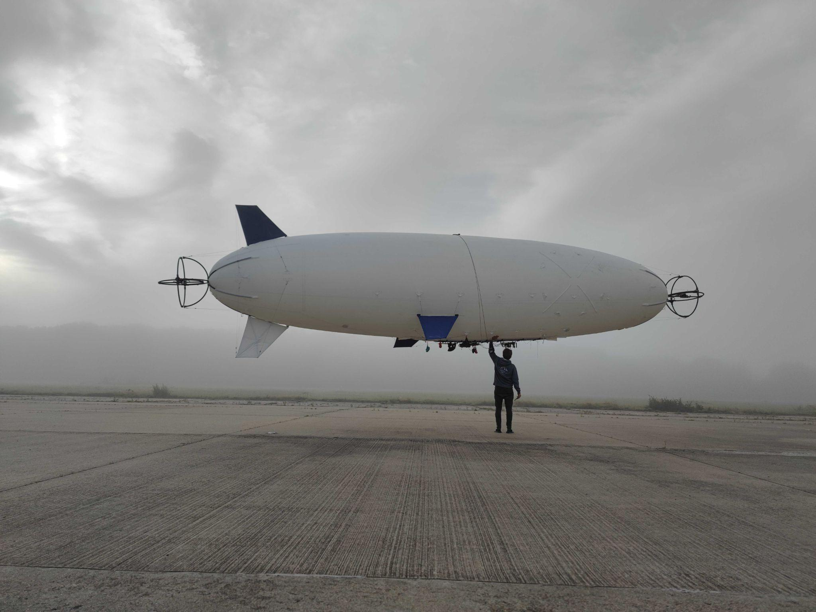
January 2025

Created by Josef Rokůsek
This technical test is designed to assess the three important aspects in working at HyLight:
- Demonstrating expertise
- Stepping out of your comfort zone and starting from scratch
- A smart conception, design and architecture is more important than tech and tools

To assess these three points, we propose 1 tests: Hi
- Powerline pictures analysis

Exercise - Powerline picture analysis
Estimated time: 4h

The Strategist :
Describing how you would build an automated tool to detect and classify defects on powerlines and pylons. Use any schema or diagram to illustrate your approach. Mention tools, data flow, and model choices.
Information regarding defects to identify :Test - Classification reseaux aeriens.pdf

The Builder :
If you want to go further in this test and try to apply directly your strategy with real data you can start directly, using the provided dataset (~600 images): Test - Powerlines pictures
- Detect and identify at least a few basic elements (e.g. pylon, conductor, insulator) and one type of defect from the list in Classification réseaux aériens.pdf.
You can use YOLO, Detectron2, or any object detection library.
- Train quickly (even on a subset) and produce example detection results.
- Save predicted images and a simple JSON/CSV of detections (class, score, bbox).
Deliverables:
strategy.pdf : your proposed approach.
README.md : how to run your code and a few sample annotated images showing detections.
(Optional) basic metrics based on the client data

